# Brainstorm

**& idea prioritization**

Use this template in your own brainstorming sessions so your team can unleash their imagination and start shaping concepts even if you're not sitting in the same room.

## Before you collaborate

### A little bit of preparation goes a long way with this session. Here’s what you need to do to get going.

**10 minutes**

#### Team gathering

Define who should participate in the session and send an invite. Share relevant information or pre-work ahead.

#### Set the goal

Think about the problem you'll be focusing on solving in the brainstorming session.

#### Learn how to use the facilitation tools

Use the Facilitation Superpowers to run a happy and productive session.

**1**

## Define your problem statement

### What problem are you trying to solve? Frame your problem as a How Might We statement. This will be the focus of your brainstorm.

**5 minutes**

**PROBLEM**

**The leakage of gases only can be detected by human nearby and if there are no human nearby, it cannot be detected. But sometimes it cannot be detected by human that has a low sense of smell.**

**Thus, this system will help to detect the presence of gas leakage**

**2**

## Brainstorm

### Write down any ideas that come to mind that address your problem statement.

**10 minutes**

**Hemachandhar.N**

**catalytic combustion of the target gas in the sensor**

oxygen levels can impact oxidation efficiency

Quick response and good selection used in city gas transmission

#### Dharshini . S

Attacking their leak detection problem

portable radon detector that is battery operated

Explosive Gas Detector also comes highly recommended.

Carbon monoxide from a leaking appliance or a vehicle running.

**3**

## Group ideas

### Take turns sharing your ideas while clustering similar or related notes as you go. In the last 10 minutes, give each cluster a sentence-like label. If a cluster is bigger than six sticky notes, try and see if you and break it up into smaller sub-groups.

**20 minutes**

**4**

## Prioritize

### Your team should all be on the same page about what's important moving forward. Place your ideas on this grid to determine which ideas are important and which are feasible.

**20 minutes**

Long-term explosure to certain gases can be toxic

Implementing a serious LDAR

program

**After you collaborate**

You can export the mural as an image or pdf to share with members of your company who might find it helpful.

**Quick add-ons**

#### Share the mural

**Share a view link** to the mural with stakeholders to keep them in the loop about the outcomes of the session.

#### Export the mural

Export a copy of the mural as a PNG or PDF to attach to emails, include in slides, or save in your drive.

IR

instruments detect simple mixtures

Laser methane gas detector

**10 minutes** to prepare

**1 hour** to collaborate

**2-8 people** recommended

#### [Open article](https://support.mural.co/en/articles/2113740-facilitation-superpowers)

Flammable mixtures that can explode when exposed to open air

High concentration of radon in your basement or crawl space

Drifts and poor reproducibility of peak areas

**Key rules of brainstorming**

Benefits are compelling

To run an smooth and productive session

**Keerthana . R**

Gas level monitor on using internet ESP8266

IR gas cloud imaging is shown up video image in dark pixels

#### Charudesna . K

Embedded system for hazardous gas accurate detection

Approximate consumption is indicated interms of the total weight.

**Keep moving forward**

**Strategy blueprint**

Define the components of a new idea or strategy.

#### [Open the template](https://app.mural.co/template/e95f612a-f72a-4772-bc48-545aaa04e0c9/984865a6-0a96-4472-a48d-47639307b3ca)

**Customer experience journey map**

Stay in topic. Defer judgment.

Auto on-off gas system appliance is generally automatic recycling type.

Solid state sensing is a broad range of gases

Handling the situation calmly can reduce the risk

Encourage wild ideas. Listen to others.

## Importance

|  |  |  |
| --- | --- | --- |
| portable detectors are able to detect very small | Expect high performance from installed systems | expect high performance |
| IoT helping in automating tasks | high concentrations  of corrosive agents | monitoring radius of 0.5  to 2 meters |
| Vapors created from leaking liquids | close to the limits of local detection coverage | IR detectors are unaffected by poisons |

If each of these

Understand customer needs, motivations, and obstacles for an experience.

#### [Open the template](https://app.mural.co/template/b7114010-3a67-4d63-a51d-6f2cedc9633f/c1b465ab-57af-4624-8faf-ebb312edc0eb)

Security alert system using gsm

Immediately alert the consumer by sending SMS

More compatible development environments

sensors require a minimum oxygen level

Go for volume. If possible, be visual.

tasks could get

done without any difficulty or cost, which would have the most positive impact?

Reduction of lifetime of traps

Unstable baseline due to larger background noise

#### Strengths, weaknesses, opportunities & threats

Identify strengths, weaknesses, opportunities, and threats (SWOT) to develop a plan.

gas detector can sound an alarm to operators in the area

|  |  |
| --- | --- |
|  |  |
|  |  |

#### [Open the template](https://app.mural.co/template/6a062671-89ee-4b76-9409-2603d8b098be/ca270343-1d54-4952-9d8c-fbc303ffd0f2)

[**Share template feedback**](https://muralco.typeform.com/to/CiqaHVat?typeform-source=app.mural.co)

[**Share template feedback**](https://muralco.typeform.com/to/CiqaHVat?typeform-source=app.mural.co)

**Feasibility**

Regardless of their importance, which tasks are more feasible than others? (Cost, time, effort, complexity, etc.)

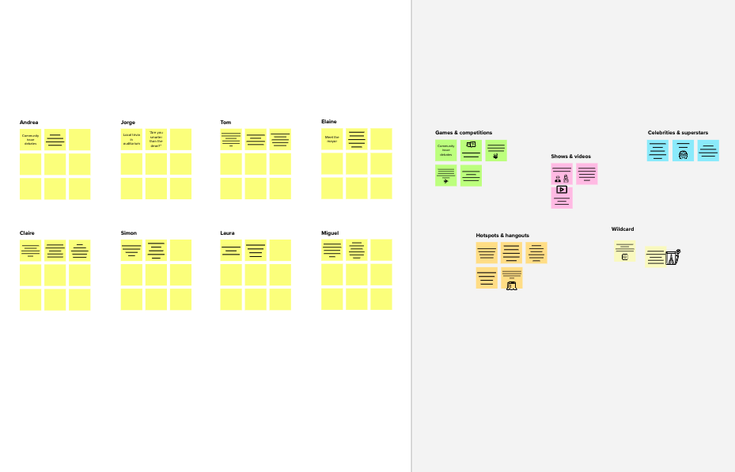

**Need some inspiration?**

See a finished version of this template to kickstart your work.

[**Open example**](https://app.mural.co/template/e5a93b7b-49f2-48c9-afd7-a635d860eba6/93f1b98d-b2d2-4695-8e85-7e9c0d2fd9b9)